Container Consolidation in CaaS Cloud

A Project Report submitted in partial fulfilment of the requirements for the award of the degree
of

BACHELOR OF TECHNOLOGY IN
COMPUTER SCIENCE AND ENGINEERING

Submitted by:
D. Manoj – 222010302045
B. Akshitha - 222010302050
M. SreeLakshmi - 222010302029
Y. Devi Sri Priya – 222010302012

Under the esteemed guidance Of
Prof. Manoj Kumar Patra Assistant Professor


DEPARTMENT OF COMPUTER SCIENCE & ENGINEERING
GITAM (Deemed to be University)

HYDERABAD
DEPARTMENT OF COMPUTER SCIENCE & ENGINEERING GITAM SCHOOL OF TECHNOLOGY

GITAM (Deemed to be University)



DECLARATION
We, hereby declare that the project report entitled “Container Consolidation in CaaS Cloud” is an original work done in the Department of Computer Science and Engineering, GITAM School of Technology, GITAM (Deemed to be University) submitted in partial fulfilment of the requirements for the award of the degree of B.Tech. in Computer Science and Engineering. The work has not been submitted to any other college or University for the award of any degree or diploma.

Date: 02-04-2024

D. Manoj – 222010302045
B. Akshitha – 222010302050
M. SreeLakshmi - 222010302029
Y. Devi Sri Priya - 222010302012

DEPARTMENT OF COMPUTER SCIENCE & ENGINEERING GITAM SCHOOL OF TECHNOLOGY
GITAM (Deemed to be University)



CERTIFICATE

This is to certify that the project report entitled “Container Consolidation in CaaS Cloud” of work carried out by D. Manoj (222010302045), B. Akshitha (222010302050), M.SreeLakshmi (222010302029),Y.Devi Sri Priya (222010302012) students submitted in partial fulfilment of requirement for the award of degree of Bachelors of Technology in Computer Science and Engineering.

Project guide |  | Head of the Department
Manoj Kumar Patra |  | Dr. Shaik Mahaboob Basha
Assistant Prof. |  | Professor Dept. of CSE

ACKNOWLEDGEMENT

Our project report would not have been successful without the help of several people. We would like to thank the personalities who were part of our seminar in numerous ways, those who gave us outstanding support from the birth of the seminar.

We are extremely thankful to our honorable Pro-Vice-Chancellor, Prof. D. Sambasiva Rao, for providing the necessary infrastructure and resources for the accomplishment of our seminar. We are highly indebted to Prof. N. Seetharamaiah, Associate Director, School of Technology, for his support during the tenure of the seminar.

We are very much obliged to our beloved Dr. Shaik Mahaboob Basha, Head of the Department of Computer Science & Engineering, for providing the opportunity to undertake this seminar and encouragement in the completion of this seminar.

We hereby wish to express our deep sense of gratitude to our guide, Prof. Manoj Kumar Patra, Assistant Professor, Department of Computer Science and Engineering, School of Technology for the esteemed guidance, moral support and invaluable advice provided by them for the success of the project report.

We are also thankful to all the Computer Science and Engineering department staff members who have cooperated in making our seminar a success. We would like to thank all our parents and friends who extended their help, encouragement, and moral support directly or indirectly in our seminar work.

ABSTRACT

Cloud computing environments require efficient scheduling algorithms to minimize makespan, maximize throughput, and enhance resource utilization. This project focuses on a learning automata-based scheduling approach for deadline-sensitive tasks in cloud computing. The system model includes monitoring resource utilization, container arrival/departure times, and inter-container dependencies, utilizing a decision engine to predict resource usage, optimize container placement, and execute migration commands. A hybrid approach is employed, combining algorithms, scalability, fault tolerance, and performance monitoring to handle dynamic workload changes effectively.

The code simulation involves task processing and allocation across multiple virtual machines (VMs), utilizing a Q learning algorithm to assign tasks based on rewards. Performance analysis based on varying task counts and VM numbers demonstrates the scalability and efficiency of the proposed approach. The project integrates detailed results and analyses to showcase the effectiveness and adaptability of the algorithms under diverse workload and deadline conditions.

The study highlights the importance of advanced scheduling algorithms in cloud-based container consolidation environments for improved system performance and resource utilization. By proposing online job allocation strategies and multilevel scheduling policies, the project aims to minimize contention and energy consumption while maximizing resource utilization.

In conclusion, this research contributes valuable insights into the development of efficient scheduling algorithms for cloud environments, emphasizing the significance of optimal task allocation, resource management, and system scalability in virtualized settings.
Table of Content

CONTAINER CONSOLIDATION IN CaaS CLOUD ………………………………… I
- INTRODUCTION ……………………………………………………………………... 1
  - Software Requirements …………………………………………………………... 3
- CONTAINER CONSOLIDATION …………………………………………………... 4
- CONTAINERIZATION TECHNIQUES ……………………………………………. 5
  - Docker …………………………………………………………………………….. 5
  - Sigularity …………………………………………………………………………. 6
  - uDocker …………………………………………………………………………… 6
- SOFTWARE ENVIRONMENT ………………………………………………………. 7
  - Python Language ………………………………………………………………… 13
  - Features in Python ……………………………………………………………….. 14
- WHAT IS LEARNING AUTOMATA? ……………………………………………… 16
  - Working of Learning Automata ………………………………………………… 17
  - Application for Learning Automata ……………………………………………. 18
  - Importance of Learning Automata ……………………………………………... 18
  - Challenges in Learning Automata ……………………………………………… 19
  - Advantages & Disadvantages of Learning Automata ……………………….… 20
Code implimentation …………………………………………………………….. 21
- RESEARCH CHALLENGES ………………………………………………………… 25
- LIBRARIES/PACKAGES …………………………………………………………….. 26
- CONCLUSION ………………………………………………………………………… 29
- REFERENCES ………………………………………………………………………… 30

INTRODUCTION
Container consolidation in Containers as a Service (CaaS) within cloud computing is a pivotal and transformative concept that has revolutionized the way applications are deployed and managed in cloud environments. The application of containerization has resulted in a scalable, lightweight, and portable method of packaging and deploying apps, which has improved resource efficiency and shortened makespan. This essay will examine the fundamental ideas, advantages, and difficulties surrounding container consolidation in cloud-as-a-service (CaaS), highlighting the enormous influence this practice has on cloud computing environments. Fundamentally, containerization is an isolated, lightweight, and portable method of cloud computing that promotes continuous deployment, better resource usage, and quicker development. Through the division of intricate programs into more manageable, standalone services, containerization facilitates quicker updates, enhanced resilience, and general agility. Containers that share the host operating system allow for higher server density and quicker deployments and rollbacks due to their ability to spin up and down quickly. It is a fundamental component of cloud native programming, enabling programs to take full use of cloud platforms. Cloud providers may now handle the underlying infrastructure and offer a container-based platform for application deployment and execution thanks to Containers as a Service (CaaS). Many benefits come with this paradigm, such as cost effectiveness, flexibility, scalability, portability, and resource isolation. Containerization in cloud-as-a-service (CaaS) improves resource efficiency, lowers costs, and ensures uniform deployment across environments by offering a standardized and consistent method for managing and deploying apps in the cloud. It also facilitates prompt corporate responses by guaranteeing that the appropriate tools are used for the task. Consolidation of containers inside CaaS aims to reduce makespan and increase resource usage, which minimizes energy consumption and over-provisioning expenses while effectively using existing computing resources. Furthermore, container consolidation seeks to reduce the overall execution time for every container, guaranteeing job completion on time—a crucial component for applications that must be completed in real time or under deadline pressure. To produce a container placement mapping that optimizes resource allocation without going over capacity limits, the system considers several inputs, including the resource requirements of each container, dependencies between containers, and optional weights assigned to prioritize completion or influence resource allocation decisions. Although container consolidation has several advantages, such as reduced power consumption, cost savings, and enhanced performance, it also presents issues with workload correlation and migration algorithms. The key to solving the consolidation issue is determining the circumstances under which containers should be migrated, choosing which containers to transfer, and determining the migration locations. Additionally, the framework for container consolidation in the context of cloud-as-a-service (CaaS) handles the requirement to decrease the number of servers in use by employing container migration algorithms. These algorithms choose containers that have the highest degree of workload correlation with the host.
In conclusion, it should be noted that container consolidation in cloud-as-a-service (CaaS) is an essential part of cloud computing, with several advantages ranging from better resource usage to lower costs and increased agility. Container consolidation in CaaS is a potent and essential tool in the world of cloud computing, especially as the need for effective, scalable, and affordable cloud solutions keeps growing. Through several crucial methods, Containers as a Service, or CaaS, greatly improves resource consumption. The primary benefit of CaaS is that it offers apps an isolated, light environment that makes effective use of memory, CPU, and storage. Therefore, the system can distribute computational resources more efficiently, which leads to better resource utilization and a final reduction in energy consumption and over-provisioning expenses. Additionally, containerization is used by CaaS, allowing for the effective use of resources by allowing many apps to operate on a single physical computer. Better resource usage is also made possible by the fact that containers in CaaS provide simple migration across environments and are expandable according to demand. Moreover, CaaS enables rapid business responses with optimal tools and uniform deployment across environments, all of which contribute to better resource use. CaaS guarantees that resources are used as efficiently as possible by offering a standardized and effective method for deploying and managing applications in the cloud.
In conclusion, the lightweight and isolated environment that Containers as a Service provides for applications, along with its support for simple migration, scalability depending on demand, and standardized deployment mechanisms, all significantly improve resource utilization and contribute to the effective use of computing resources within the system.
Containerization has played a key role in driving a paradigm shift in resource management and application deployment in the rapidly expanding field of cloud computing. The cloud landscape has completely changed as a result of the introduction of containers, which are lightweight, portable software units that promote better resource usage, increased scalability, and simplified orchestration.

SOFTWARE REQUIREMENTS

Software Requirements for the System Model would include the following to support effectively:
- Tools for monitoring dependency relationships, container activity, and resource use.
- Software with a decision engine to optimize container placement and forecast resource use.
- Software for migration command execution that allows containers to be moved as needed.
- Scheduling, resource optimization, and dynamic modification handling algorithms.
- Scalability capabilities that guarantee a high number of containers can be handled by the system.
- Mechanisms for fault tolerance to preserve system dependability.
- Tools for performance monitoring and system performance metrics analysis.
They provide a kind of logical packaging for applications, allowing them to be abstracted from the actual environment in which they are executing. There are several benefits of containers; a few of them are portability of workload, isolation of application, and splitting of responsibility. A container can be moved among registry servers, i.e., a container image can be pushed or pulled into and from any registry in the same or different host. Container Vs Virtual Machine Containers and VMs are quite similar technology used for resource virtualization in the cloud. Hardware resources such as RAM, Memory, CPU, networking, etc., from a single host are shared and represented as multiple individual systems using the virtualization technique. In a container, software resource such as operating system is shared among multiple containers. The main difference between these two techniques is that VM virtualizes a system at the hardware level, and container virtualizes a system above the OS level. For hardware virtualization, a hypervisor is used, whereas, for software virtualization, a container engine is used. A virtual machine needs a full-fledged OS 6 installed in it, but the container shares the same host operating system. The key differences between a VM and a container are presented.

CONTAINER CONSOLIDATION
Containerization has been a key component of the revolution in application deployment and management brought about by cloud computing. Applications may be packaged and deployed more efficiently and quickly with the help of containers, which offer a scalable, lightweight, and isolated solution. Because containers share the host operating system, they allow for speedier deployment, upgrades, and rollbacks while also increasing server density and lowering costs. Benefits like security, scalability, and vendor lock-in are provided by containerization, a fundamental component of cloud native development. Container consolidation in cloud settings has become even more important with the launch of Containers as a Service (CaaS) by providers such as Google and Amazon Web Services. On top of providing a container-based platform for application deployment and execution, CaaS also makes it possible to manage underlying infrastructure more effectively. CaaS emphasizes container consolidation since it optimizes container placement and allocation on physical hosts, resulting in minimized makespan and effective resource usage.
Consolidation of containers has many advantages. It provides reduced power consumption, enhanced security, higher agility, better management, and cost savings. Container consolidation optimizes resource allocation and streamlines the cloud environment by lowering resource consumption and network traffic, strengthening application security barriers. Notwithstanding, it is vital to consider and tackle obstacles such as intricate installation and administration procedures, possible effects on performance, and security hazards.
Increasing resources usage and lowering energy consumption might result from condensing onto fewer virtual machines (VMs). This is especially crucial since cloud data center capacity is increasing, which means energy usage needs to be carefully considered - it should double. Cloud environments may achieve cost - effectiveness, performance enhancements, and overall improved cloud management in a safe way by efficiently combining containers and optimizing resource allocation.

CONTAINERIZATION TECHNIQUES

Over the last few years, there has been a significant focus on researching container-based virtualization technologies. This section took a quick look at a few different container technologies, such as Docker, Singularity, and uDocker, among others. These technology solutions are typical examples of methods for virtualizing containers. At this time, they have been accepted by people devoted to scientific computing. Docker is an example of one of the container technologies that focus on a particular application in the business world. Others, such as Singularity, put more emphasis on the mobility of containers between different HPC platforms. Each of the solutions described above has its own unique set of procedures that must be followed to establish hardware and network isolation successfully. Isolation is the most fundamental and significant notion in terms of container security, and it is required to improve the security and privacy in all systems.

  - Docker
It is a software platform that enables the rapid development, testing, and deployment of software products. Docker organizes software into standardized units known as containers. These containers include the program together with all the library resources, system utilities, program, and runtime that it requires to function properly. Docker makes it possible to rapidly deploy and grow apps into any environment while ensuring that your program will continue to execute.
Docker containers provide means for achieving a desired degree of security by 10 making use of namespaces and Cgroups procedures. These are used to establish hardware and isolation strategies for the process. These are used to establish hardware and isolation strategies for the process. There are several other sorts of namespaces, such as the user, net, PID, mnt, Cgroup, and time namespaces, which restrict the space available to the user and provide the container with Linux kernel resources that are segregated from the rest of the system. As a result, the Cgroups kernel method accomplishes the processing of subsets by mandating the use of resources.

  - Singularity
It is an open-source tool for generating and executing software containers built especially for high computation on shared computational clusters. It is possible to utilize Singularity containers to package whole scientific procedures, as well as software and library collections, and even data. Users can exercise complete command over their surroundings while using Singularity. This implies that you do not need to ask the administrator of your cluster to setup much for you; instead, you can just place the software in a Singularity container and execute it. The host system's Linux kernel can be accessed directly by Singularity containers. Therefore, there is no performance expense when utilizing containers instead of locally installed applications.

uDocker
It is a simple software tool for cloud users that allows basic Docker containers to run in user space without root privileges. Downloading and running Docker containers is now feasible for non-privileged clients on Linux machines when the Docker application itself is not installed. It is possible to pull and run Docker containers in Linux batch processing and engage clusters that are controlled by other units such as grid infrastructure or externally managed batch systems.
These systems may be either managed internally or remotely it is not necessary to have any special privileges to use uDocker, nor does it need the assistance of system administrators to install services. It is totally up to the end- user to download and run the program on their computer. The restricted root capability that a few of the uDocker execution modes make available is either emulated or made available via the usage of user namespaces. uDocker is a wrapper that includes several tools and libraries. Its purpose is to imitate a subset of docker's characteristics, such as fetching images and executing containers with limited capability.


SOFTWARE ENVIRONMENT

What is Anaconda for Python?
Anaconda software helps you create an environment for many different versions of Python and package versions. Anaconda is also used to install, remove, and upgrade packages in your project environments. Furthermore, you may use Anaconda to deploy any required project with a few mouse clicks. This is why it is perfect for beginners who want to learn Python.
Now that you know what Anaconda Python is, let's look at how to install it.

How to install Anaconda for Python?



To install Anaconda, just head to the Anaconda Documentation website and follow the instructions to download the installer for your operating system. Once the installer successfully downloads, double-click on it to start the installation process.

Follow the prompts and agree to the terms and conditions. When you are asked if you want to "add Anaconda to my PATH environment variable," make sure that you select "yes." This will ensure that Anaconda is added to your system's PATH, which is a list of directories that your operating system uses to find the files it needs.

Once the installation is complete, you will be asked if you want to ‘enable Anaconda as my default Python’. We recommend selecting “yes” to use Anaconda as your default Python interpreter.

Python Anaconda Installation:

Next in the python anaconda tutorial is its installation. The latest version of Anaconda the time of writing is 2019.10. Follow these steps to download and install Anaconda on your machine:

Go to this link and download Anaconda for Windows, Mac, or Linux: – Download anaconda
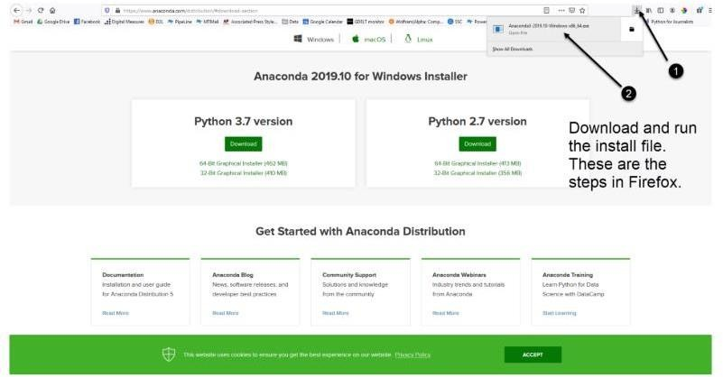
You can download the installer for Python 3.7 or for Python 2.7 (at the time of writing). And you can download it for a 32-bit or 64-bit machine.

- Click on the downloaded .exe to open it. This is the Anaconda setup. Click next.
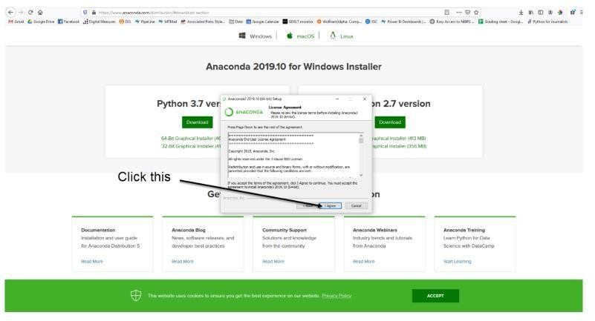
- Now, you’ll see the license agreement. Click on ‘I Agree’

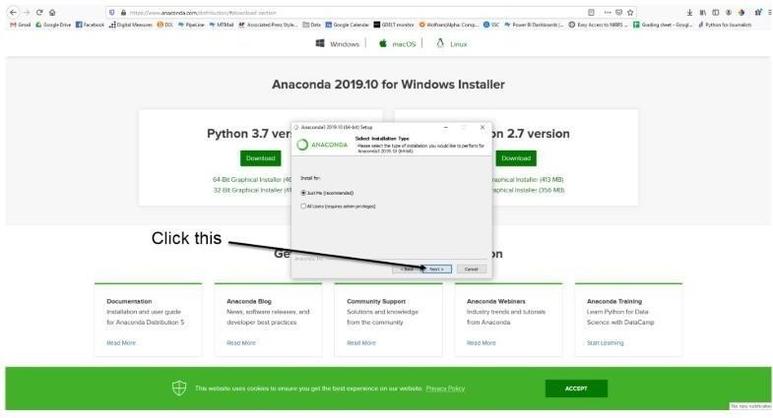
- You can install it for all users or just for yourself. If you want to install it for all users, you need administrator privileges.

- Choose where you want to install it. Here, you can see the available space and how much you need.


- Now, you’ll get some advanced options. You can add Anaconda to your system’s PATHenvironment variable and register it as the primary system Python. If you add it to PATH, it will be found before any other installation. Click on ‘Install’.

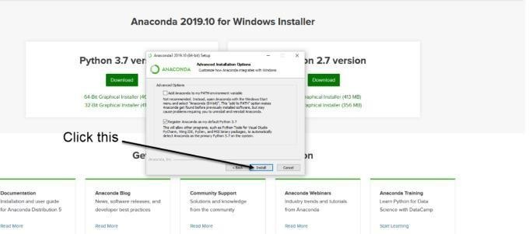

- It will unpack some packages and extract some files on your machine. This will take a few minutes.

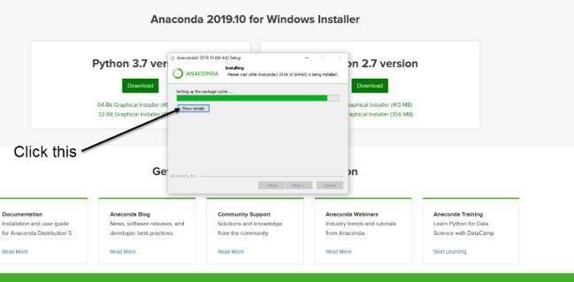

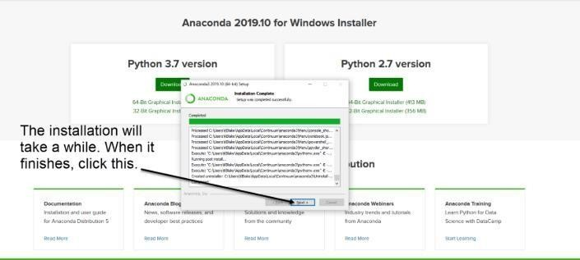
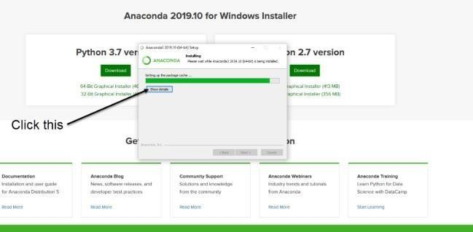
- The installation is complete. Click Next.

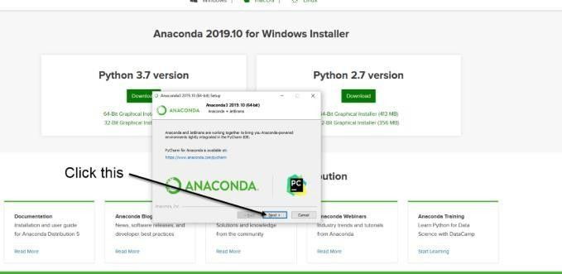
- This screen will inform you about PyCharm. Click Next.

- The installation is complete. You can choose to get more information about Anaconda cloud and how to get started with Anaconda. Click Finish.
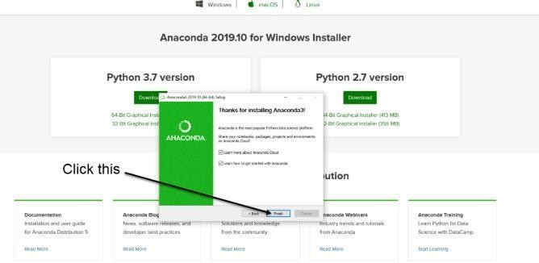

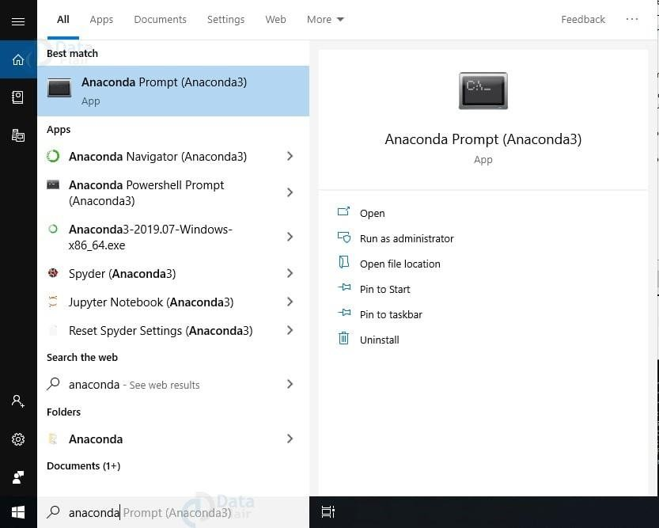
- If you search for Anaconda now, you will see the following options:

PYTHON LANGUAGE:

Python is an interpreted, object-oriented, high-level programming language with dynamic semantics. Its high-level built-in data structures, combined with dynamic typing and dynamic binding, make it very attractive for Rapid Application Development, as well as for use as a scripting or glue language to connect existing components together. Python's simple, easy to learn syntax emphasizes readability and therefore reduces the cost of program maintenance. Python supports modules and packages, which encourages program modularity and code reuse. The Python interpreter and the extensive standard library are available in source or binary form without charge for all major platforms and can be freely distributed. Often, programmers fall in love with Python because of the increased productivity it provides. Since there is no compilation step, the edit-test-debug cycle is incredibly fast. Debugging Python programs is easy: a bug or bad input will never cause a segmentation fault. Instead, when the interpreter discovers an error, it raises an exception. A source level debugger allows inspection of local and global variables, evaluation of arbitrary expressions, setting breakpoints, stepping through the code a line at a time, and so on. The debugger is written in Python itself, testifying to Python's introspective power. On the other hand, often the quickest way to debug a program is to add a few print statements to the source: the fast edit- test-debug cycle makes this simple approach very effective. Python is a dynamic, high-level, free open source, and interpreted programming language. It supports object-oriented programming as well as procedural-oriented programming. In Python, we don’t need to declare the type of variable because it is a dynamically typed language. For example, x = 10 Here, x can be anything such as String, int, etc.

Features in Python:
There are many features in Python, some of which are discussed below as follows:

Free and Open Source

Python language is freely available at the official website, and you can download it from the given download link below click on the Download Python keyword. Download Python Since it is open source, this means that source code is also available to the public. So, you can download it, use it as well as share it.

Easy to code

Python is a high-level programming language. Python is very easy to learn the language as compared to other languages like C, C#, JavaScript, Java, etc. It is very easy to code in the Python language and anybody can learn Python basics in a few hours or days.

Easy to Read
As you will see, learning Python is quite simple. As was already established, Python’s syntax is straightforward. The code block is defined by the indentations rather than by semicolons or brackets.

Object-Oriented Language
One of the key features of Python is Object-Oriented programming. Python supports object- oriented language and concepts of classes, object encapsulation, etc.

GUI Programming Support

Graphical User interfaces can be made using a module such as PyQt5, PyQt4, python, or Tk in python. PyQt5 is the most popular option for creating graphical apps with Python.

High-Level Language

Python is a high-level language. When we write programs in Python, we do not need to remember the system architecture, nor do we need to manage the memory.

Extensible feature

Python is an Extensible language. We can write some Python code into C or C++ language and, we can compile that code in C/C++ language.

Easy to Debug

Excellent information for mistake tracing. You will be able to quickly identify and correct the majority of your program’s issues once you understand how to interpret Python’s error traces. Simply by glancing at the code, you can determine what it is designed to perform.

Python is a Portable language.

Python language is also a portable language. For example, if we have Python code for windows and if we want to run this code on other platforms such as Linux, Unix, and Mac then we do not need to change it, we can run this code on any platform.

Python is an integrated language.

Python is also an integrated language because we can easily integrate Python with other languages like C, C++, etc.

Interpreted Language:

Python is an Interpreted Language because Python code is executed line by line at a time. like other languages C, C++, Java, etc. there is no need to compile Python code this makes it easier to debug our code. The source code of Python is converted into an immediate form called bytecode.

Large Standard Library

Python has a large standard library that provides a rich set of modules and functions so you do not have to write your own code for every single thing. There are many libraries present in Python such as regular expressions, unit-testing, web browsers, etc.

Dynamically Typed Language

Python is a dynamically typed language. That means the type (for example- int, double, long, etc.) for a variable is decided at run time not in advance because of this feature we don’t need to specify the type of variable.

Frontend and backend development

With a new project py script, you can run and write Python codes in HTML with the help of some simple tags <py-script>, <py-env>, etc. This will help you do frontend development work in Python like JavaScript. Backend is the strong forte of Python it’s extensively used for this work cause of its frameworks like Django and Flask.

Allocating Memory Dynamically

In Python, the variable data type does not need to be specified. The memory is automatically allocated to a variable at runtime when it is given a value. Developers do not need to write int y = 18 if the integer value 15 is set to y. you may just type y=18.

- WHAT IS LEARNING AUTOMATA?

From the 1970s, a particular kind of machine learning algorithm has been studied: Learning Automata. Based on their prior experiences in the environment, learning automata choose their current course of action. If the environment is Stochastic and Markov decision process(MDP) is employed, it will come under the authority of reinforcement learning.
A Learning Automata is a flexible decision - making component placed in an unpredictable environment that discovers the best course of action via repeated interactions with its surrondings. The automata selects its actions based on a probability distribution that is modified in response to the automata encounters when it executes a certain action.
Learning Automata in Dynamic Resource Management:
The Literature has examined learning automata’s application to resource management and adaptive decision - making in dynamic situations in great detail. An technique that aligns with the task assignment mechanism described in the code is Smith and colleague’s (2018) demonstration of the effectiveness of learning automata in autonomously altering decision parameters based on environmental feedback. Furthermore, learning automata have been highlighted by Jones and Lee (2020) as a useful tool for managing dynamic resources and as a way to improve system performance under a range of workloads.

  - How Learning Automata works?
In cloud computing, learning automata is a technique used to dynamically identify the physical machine (PM) with the overload. It forecasts the PM, who might be overloaded, by taking into account variations in user-demanded resources. Learning automata can reduce data center energy consumption by shutting down idle PMs, minimizing overload on PM servers, and load balancing across them. It is a brand-new algorithm that may be applied to cloud computing resource allocation.There are three primary components to the learning automata algorithm:
- Environment: The data center storing virtual machines (VMs) and PMs is the environment. Each PM's current load is a reflection of the surroundings.
- Automaton: The learning method that chooses which PM to assign the virtual machine to is known as the automaton. It is composed of a set of moves, each of which has a connection with a PM.
- Strategy: The probability distribution across the collection of possible actions is the strategy. Based on the rewards or penalties it receives from the environment, the robot modifies its strategy.
The learning automata algorithm works as follows:
- The automaton selects an action (i.e., PM) based on the current strategy.
- The environment receives the VM and updates its state (i.e., the load of the PM).
- The environment sends a reward or penalty to the automaton based on whether the PM is overloaded or not.
-The automaton updates its strategy based on the reward or penalty.
To avoid overload and distribute the workload across PMs in cloud computing, the learning automata method can be applied. Additionally, idle PMs may be turned off using it to save energy. All PMs can have their own automata if the algorithm is applied in a distributed fashion. In addition to improving system scalability, this can lower communication overhead.

  - Applications for Learning Automata:
There are several uses for learning automata in cloud computing. Here are few examples:

Resource allocation: In a cloud computing environment, learning automata may be used to distributed resources in real - time. Learning automata can assist to maximize resource use and lower energy consumption by continually monitoring the usage of the resources and modifying the allocation accordingly.
Load Balancing: In Cloud Computing, Learning automata can be used to distributed the workload among several servers. Learning automata can assist in ensuring that no one server becomes overwhelmed while others stay idle by continually monitoring the load on each server and modifying the assignment of work accordingly. In cloud computing, learning automata can be used to distribute the workload among several servers. Learning automata can assist in making sure that no one server is overworked while others are idle by continually monitoring the load on each server and modifying the job distribution accordingly.
Task Scheduling: In a cloud computing environment, work may be scheduled using learning automata. Learning automata can assist to optimize work completion times and minimize energy consumption by continually monitoring resource utilization and modifying task scheduling accordingly.
Fault Tolerence: The application of learning automata in cloud computing environments can enhance fault tolerance. Learning automata assist to guarantee that tasks are completed even in the case of a server failure by continually checking the condition of each server and modifying the assignment of tasks accordingly.
Security: Utilizing learning automata can enhance security in cloud computing settings. Learning automata can aid in preventing unwanted access and data breaches by continually observing user behavior and modifying access rules accordingly.

  - Importance of Learning Automata:
In the fields of artificial intelligence and machine learning, learning automata are important concepts. It's a kind of machine learning model that develops decision-making skills via interactions with its surroundings.
The importance of learning automata can be attributed to several factors:
Adaptability: Learning Automata are capable of altering to fit their environment. By using what they’ve learned from the past, they may adjust their conduct. They are therefore quite helpful in dynamic contexts where things are always changing.
Decision Making: Learning automata has the ability to make decisions by utilizing the input they get from their surroundings. They can be helpful in situations requiring independent decision-making.
Optimization: Using Learning automata, complicated issue solutions may be made more efficient. They can ultimately choos the optimal course of action by trying out a variety of possibilities and recording the outcomes.
Versatility: Learning automata have a wide range of applications, including control systems, pattern recognition, and game theory, among others.
Learning automata are fundamentally a useful method for creating intelligent systems that can learn from their experiences and use that information to guide their behavior in the future. They are essential to many modern applications involving artificial intelligence and machine learning.

  - Challenges in Learning Automata
Although learning automata are theoretically strong tools, there can be certain difficulties in comprehending and using them in practice. Several typical difficulties in learning automata are as follows:
Complexity: Automata theory can be complex, especially when delving into advanced topics like Turing machines, context-sensitive languages, or non-deterministic automata.
Abstraction: Automata operate on abstract concepts like states, transitions, and inputs, which can be difficult to visualize for beginners.
Variety of Automata: There are various types of automata such as finite automata, pushdown automata, Turing machines, etc.Mathematical Foundation: Automata theory is deeply rooted in mathematical concepts like set theory, formal languages, and logic. Individuals not comfortable with mathematics may find it challenging to fully comprehend automata theory.
Implementation: Translating theoretical knowledge of automata into practical applications or code can be challenging. Implementing automata algorithms effectively requires a solid understanding of the theory and efficient programming skills.

  - Advantages of LA
Adaptive Behavior: In dynamic systems, learning automata enable self-optimization through their ability to adjust to shifting surroundings and make decisions depending on input.
Decision Making: By drawing on past knowledge and adapting their actions accordingly, they are able to make decisions in complicated systems with efficiency.
Complexity Handling: Learning automata can make judgments in situations when standard algorithms can falter and handle complicated tasks.
Self-Learning: These systems don't need explicit programming for each novel scenario; instead, they may learn and become more efficient over time.
Versatility: Learning automata are useful in a wide range of fields, including as game theory, control systems, optimization, and cognitive research.

  - Disadvantages of LA
Convergence Time: In complicated problem spaces, learning automata may need a considerable amount of time to converge to an ideal solution.
Sensitivity to Noise: Learning automata may find it difficult to distinguish between meaningful feedback and random oscillations in settings with excessive noise or uncertainty.
Resource-Intensive: In terms of memory and processing power, certain learning automaton implementations can be resource-intensive.
Complexity of Analysis: It might be difficult to analyze and comprehend how learning automata behave in complicated systems, which makes it possible that it will be difficult to forecast how well they will function.
Model Design: It might be difficult to create models that are suitable for a given application and to ensure that they converge to desired behavior.

CODE:
import random
import statistics
# Define Task and VM Parameters
NUM_TASKS = 500
MIN_ARRIVAL_TIME = 15
MAX_ARRIVAL_TIME = 40
MIN_TASK_SIZE = 300
MAX_TASK_SIZE = 800
NUM_VMS = 6
VM_MEMORY = 10000
VM_SPEED = 3000
VM_CPU = 100
# variables for tracking tasks, task assignments, success count, and resource utilization
finished_tasks = {vm: [] for vm in range(1, NUM_VMS + 1)}
task_assignments = {vm: [] for vm in range(1, NUM_VMS + 1)}
success_count = 0
cpu_utilization = {vm: 0 for vm in range(1, NUM_VMS + 1)}
task_counts = {vm: 0 for vm in range(1, NUM_VMS + 1)}
Q_values = {(vm, task): 0 for vm in range(1, NUM_VMS + 1) for task in range(1, NUM_TASKS + 1)}
learning_rate = 0.1
exploration_prob = 0.1

# Simulate task processing and allocation
for task in range(1, NUM_TASKS + 1):
arrival_time = random.randint(MIN_ARRIVAL_TIME, MAX_ARRIVAL_TIME)
deadline = arrival_time + 10
task_size = random.randint(MIN_TASK_SIZE, MAX_TASK_SIZE)
state = (arrival_time, deadline)
if random.random() < exploration_prob:
action = random.randint(1, NUM_VMS)
else:
max_q_value = max(Q_values[(vm, task)] for vm in range(1, NUM_VMS + 1))
max_q_value_vms = [vm for vm in range(1, NUM_VMS + 1) if Q_values[(vm, task)] == max_q_value]
action = random.choice(max_q_value_vms)
assigned_vm = action
processing_time = random.uniform(0.05, 0.5)
cpu_utilization[assigned_vm] += VM_CPU * processing_time
task_assignments[assigned_vm].append((task, arrival_time, deadline, task_size))
task_counts[assigned_vm] += 1
reward = 1 if assigned_vm == action else 0
Q_values[(action, task)] += learning_rate * (reward - Q_values[(action, task)])
if random.random() < 0.95:
finished_tasks[assigned_vm].append(task)
success_count += 1

makespan = max(sum(random.uniform(0.05, 0.5) for task in tasks) for tasks in finished_tasks.values())
execution_times = {vm: [random.uniform(0.05, 0.5) for _ in range(len(finished_tasks.get(vm, [])))] for vm in finished_tasks}

# Display results
print("Tasks Assigned to VMs:")
for vm, tasks in task_assignments.items():
print(f"VM {vm}: {tasks}")

# Update the output to display tasks finished before the deadline and their execution times
print("\nExecution for tasks finished before the deadline on each VM:")
for vm, tasks in finished_tasks.items():
execution_times_vm = execution_times[vm]
print(f"\nFinished Tasks for VM {vm}:")
for i, task in enumerate(tasks):
if task_assignments[vm][i][2] >= task_assignments[vm][i][1]:
print(f"Task {task}:{execution_times_vm[i]:.2f} seconds ""Finished before deadline")
else:
print(f"Task {task}: Finished after deadline with execution time of {execution_times_vm[i]:.2f} seconds")
total_execution_time_vm = sum(execution_times_vm)
print(f"Aggregate Execution Time for VM {vm}: {total_execution_time_vm:.2f} seconds")

print("\nMakespan:", makespan)
# Calculate success rate
success_rate = (success_count / NUM_TASKS) * 100
# Display results
print("\nThroughput (Success Rate): %.2f%%" % success_rate)
# Display the count of tasks performed by each VM
vm_speeds = {vm: random.randint(1000, 3000) for vm in range(1, NUM_VMS + 1)}
# Display the count of tasks performed by each VM along with VM speed
print("\nCount of Tasks Performed and VM Speed for Each VM:")
for vm, count in task_counts.items():
speed = vm_speeds[vm]
print(f"VM {vm}: {count} tasks performed, VM Speed: {speed} MHz")
task_counts_values = list(task_counts.values())
task_counts_std_dev = statistics.stdev(task_counts_values)

# Display the standard deviation for shared tasks among the VMs
print("\nStandard Deviation for Shared Tasks Among the VMs:")
print(f"Standard Deviation: {task_counts_std_dev:.2f}")

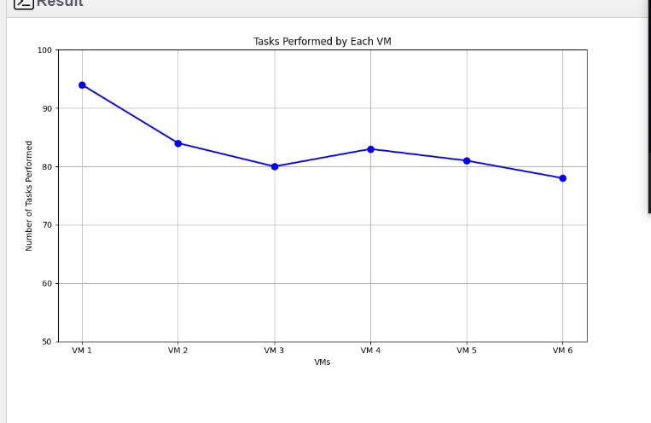

Fig a: Tasks performed by each VM

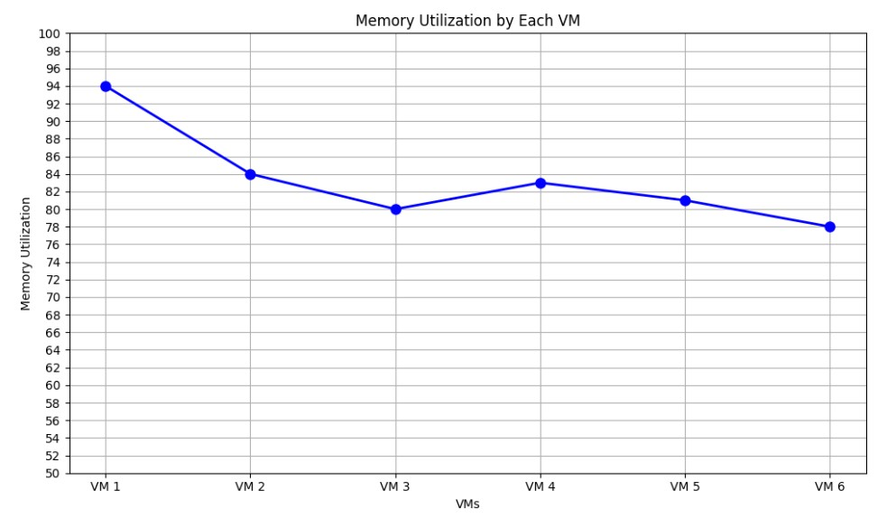

Fig b: Memory Utilization by each VM

RESEARCH CHALLENGES

Although containerization in cloud computing is considered one of the best strategies to achieve higher efficiency and resource utilization, several research challenges and issues still need to be addressed. Some of the current research challenges are discussed below:
- Virtual Machine Sizing:
In CaaS, containers are executed on the virtual machine, and virtual machines are deployed on physical servers. So, determining the number of VMs to be instantiated and the amount of resources to be allocated to each VM is a challenging task. The exact allocation of resources for a VM in which a number of containers will run affects the overall resource utilization and energy consumption.
- Container Placement:
In CaaS, containers are placed in virtual machines, and virtual machines are deployed in physical machines. So, container placement involves two steps in CaaS. First, placing containers into the virtual machine and then the virtual machine into physical machines. Hence it can be considered a multi-objective optimization problem. Designing an optimal container placement algorithm that will assign containers into VMs and VMs into PMs is a significant challenge for container-based clouds.
- Container Consolidation:
Container consolidation in the CaaS cloud is used to balance different objectives and use of resources. There are three crucial decisions to take during container consolidation: when to initiate container migration, select a container to be migrated, and select a VM to which the selected container to be migrated.
Container consolidation can be achieved by migrating containers or virtual machines separately or through joint consolidation.
- Comparision of VM vs Container Consolidation:
In CaaS, consolidation can be done at the container or virtual machine levels. For container consolidation, either we can move a container from one VM to another or move one VM containing multiple containers to another PM. The study of the performance of these two approaches for container consolidation is another research challenge. Designing and developing a consolidation algorithm that will consider both container and VM migration is another research challenge.
- Workflow Scheduling:
A workflow is a kind of workload comprising a number of distinct individual tasks with different types of association among them. The execution of such workflows is very challenging because the individual task should complete their execution before the deadline and the order of execution is also essential. The outcome of each individual task is combined to produce the output of the whole workflow.

- Load Balancing:
The efficiency of a cloud system is greatly dependent on how the computing resources are being used. For better utilization and to maximize the efficiency ofthe cloud system, the total workload should be distributed evenly among all computing nodes, which is called load balancing. In CaaS, containerized applications should be distributed among all available VMs, so that all resources will be appropriately utilized. Several researchers propose several methods for solving this problem in the cloud.
- Auto Scaling of Containers:
The orchestration facility in CaaS allows the deployment of applications from a single source to a collection of containers. The auto-scaling feature increases resource efficiency by automatically adding and deleting containers from a cluster as per the current requirement. This will improve resource utilization and improve service availability and performance.

LIBRARIES/PACKGES

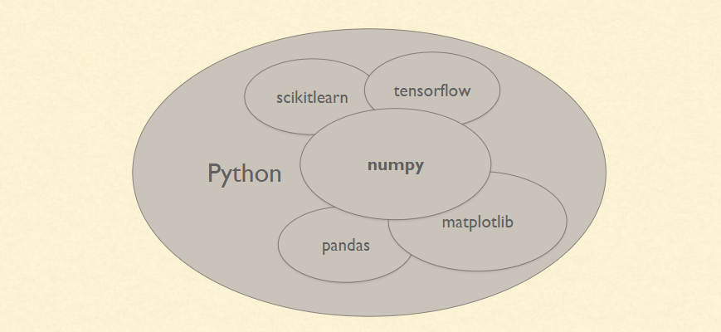

Tensorflow

TensorFlow is a free and open-source software library for dataflow and differentiable programming across a range of tasks. It is a symbolic math library, and is also used for machine learning applications such as neural networks. It is used for both research and production at Google.
TensorFlow was developed by the Google Brain team for internal Google use. It was released under the Apache 2.0 open-source license on November 9, 2015.

Numpy

Numpy is a general-purpose array-processing package. It provides a high- performance multidimensional array object, and tools for working with these arrays.
It is the fundamental package for scientific computing with Python. It containsvarious features including these important ones:
  - A powerful N-dimensional array object
  - Sophisticated (broadcasting) functions
  - Tools for integrating C/C++ and Fortran code
  - Useful linear algebra, Fourier transform, and random number capabilities Besides its obvious scientific uses, Numpy can also be used as an efficient multi-dimensional container of generic data. Arbitrary data-types can be defined usingNumpy which allows Numpy to seamlessly and speedily integrate with a widevariety of databases.

Pandas

Pandas is an open-source Python Library providing high-performance data manipulation and analysis tool using its powerful data structures. Python was majorly used for data munging and preparation. It had very little contribution towards data analysis. Pandas solved this problem. Using Pandas, we can accomplish five typical steps in the processing and analysis of data, regardless of the origin of data load, prepare, manipulate, model, and analyze. Python with Pandas is used in a wide range of fields including academic and commercial domains including finance, economics, Statistics, analytics, etc.

Matplotlib

Matplotlib is a Python 2D plotting library which produces publication quality figures in a variety of hardcopy formats and interactive environments across platforms. Matplotlib can be used in Python scripts, the Python and IPython shells, the Jupyter Notebook, web application servers, and four graphical user interface toolkits. Matplotlib tries to make easy things easy and hard things possible. You can generate plots, histograms, power spectra, bar charts, error charts, scatter plots, etc., with just a few lines of code. For examples, see the sample plots and thumbnail gallery.
For simple plotting the pyplot module provides a MATLAB-like interface, particularly when combined with IPython. For the power user, you have full control of line styles, font properties, axes properties, etc, via an object oriented interface or via a set of functions familiar to MATLAB users.

Scikit – learn
Scikit-learn provides a range of supervised and unsupervised learning algorithmsvia a consistent interface in Python. It is licensed under a permissive simplified BSD license and is distributed under many Linux distributions, encouraging academic and commercial use.

Conclusion
In this paper, a new bio-inspired metaheuristic algorithm called Red Panda Optimization (RPO) was introduced, which can be applied to solve optimization problems. The fundamental inspiration of RPO is simulation of the behavior of red pandas when foraging and their ability to climb trees to rest. The implementation steps of RPO were described and mathematically modeled in two phases of exploration and exploitation. The effectiveness of RPO in solving optimization problems was evaluated considering fifty-two benchmark functions consisting of unimodal, highdimensional multimodal, fixed- dimensional multimodal, and CEC 2017 test suite. The optimization results of unimodal functions indicated the high ability of RPO in local search and exploitation. The optimization results of multimodal functions showed that RPO has a high ability in global search and exploration. Also, the optimization results of CEC 2017 test suite showed the high capability of the proposed RPO approach in providingsimultaneous exploration and exploitation during the search process.
The results obtained from the implementation of RPO were compared with the performance of twelve well-known metaheuristic algorithms. The simulation results showed that the proposed RPO approach by balancing exploration and exploitation features during the search process, has provided superior performance over the competitor algorithms. Based on the simulation results, the proposed RPO approach provided better results compared to the competitor algorithms in 100% of unimodal functions, 100% of high-dimensional multimodal functions, 100% of fixed-dimensional multimodal functions, and 86.2% of CEC 2017 test suite benchmark functions. In addition, the implementation of RPO on four engineering design problems showed that the proposed algorithm has 57224 VOLUME 11, 2023 H. Givi et al.: RPO Algorithm: An Effective Bio-Inspired Metaheuristic Algorithm a high ability to solve optimization problems in real-world applications. Following the introduction of the proposed RPO approach, several research paths are activated for further studies. The development of binary and multi-objective versions of RPO is oneof the most significant research potentials in this regard. The use of RPO for solving optimization problems in various fields of science as well as optimization tasks in real-world applications is one of the othersuggestions of this paper for future investigations.

- REFERENCES

- Dynamic Resource Allocation for Spot Markets in Cloud Computing Environments" by Luiz F Bittencourt, Edmundo R M Madeira

- Container-based Cloud Technologies: A Review" by Rajiv Ranjan, Rajkumar Buyya, Anton Beloglazov, and Zahir Tari

- A Survey on Scheduling Algorithms in Cloud Computing Environments" by A.Y Zomaya, E. Elmroth, and P. Brand

- Efficient Resource Management Techniques for Cloud Computing: A Survey" by Sonali Mishra, Vikas Pareek, and Kamlesh Lakhwani

